***LAB 07 CAED***

***NAME: Shaheryar Siddiqui ID: FA17-BECE-0023***

**LAB WARM-UP TASK:**

Triangle=1/2*base*height

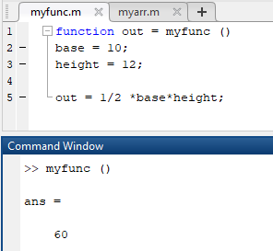

**EXERCISE 1:**

Write function which takes an input array and returns the sum and product of its elements as outputs

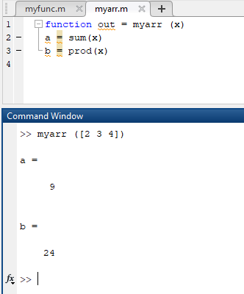

**EXERCISE 2:**

A)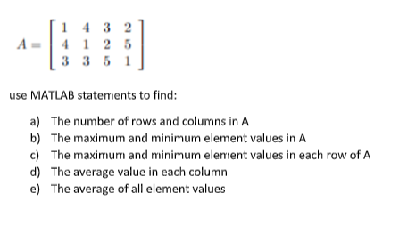

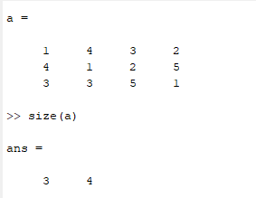

B)

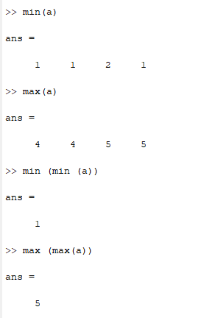

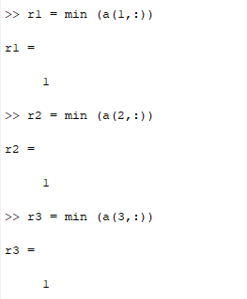C)

MINIMUM ELEMENT VALUE OF EACH ROW

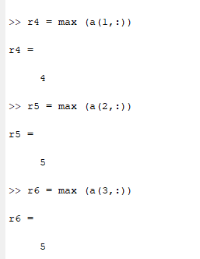

MAXIMUM ELEMENT VALUE OF EACH ROW

D)

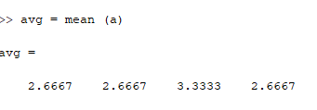

AVERAGE VALUE OF EACH COLUMN

E)

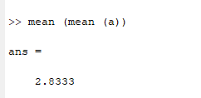

AVERAGE VALUE OF ALL ELEMENTS